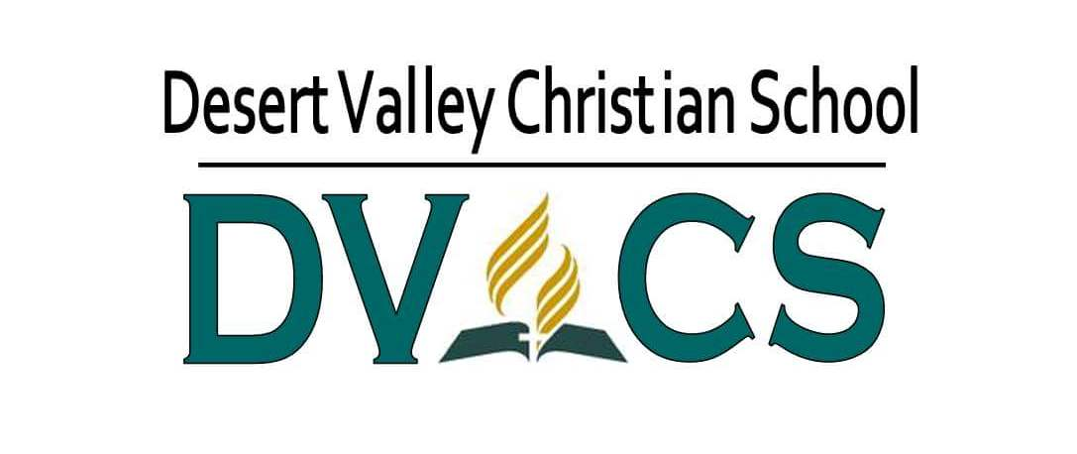

TUITION PAYMENT AGREEMENT

School Year:__________________________

Student Name:_______________________________________________

I agree to accept full financial responsibility for the above-named student. I understand that the monthly tuition is $570, minus any scholarship funds for which my child is eligible, e.g., AAA and/or IBE. I agree to be responsible for finding donors for any Arizona Tax Credit funds that may be applied to my child's tuition. I also understand that if I withdraw my child from Desert Valley Christian School before the school year ends, thereby nullifying scholarship funds, I am responsible for any unpaid balance on the account.

Parent/Guardian Name (Print):_____________________________________________________________

Parent/Guardian Signature:________________________________________________________________

Date:_______________________________

This form must be completed each year.

Rev. 6/19

