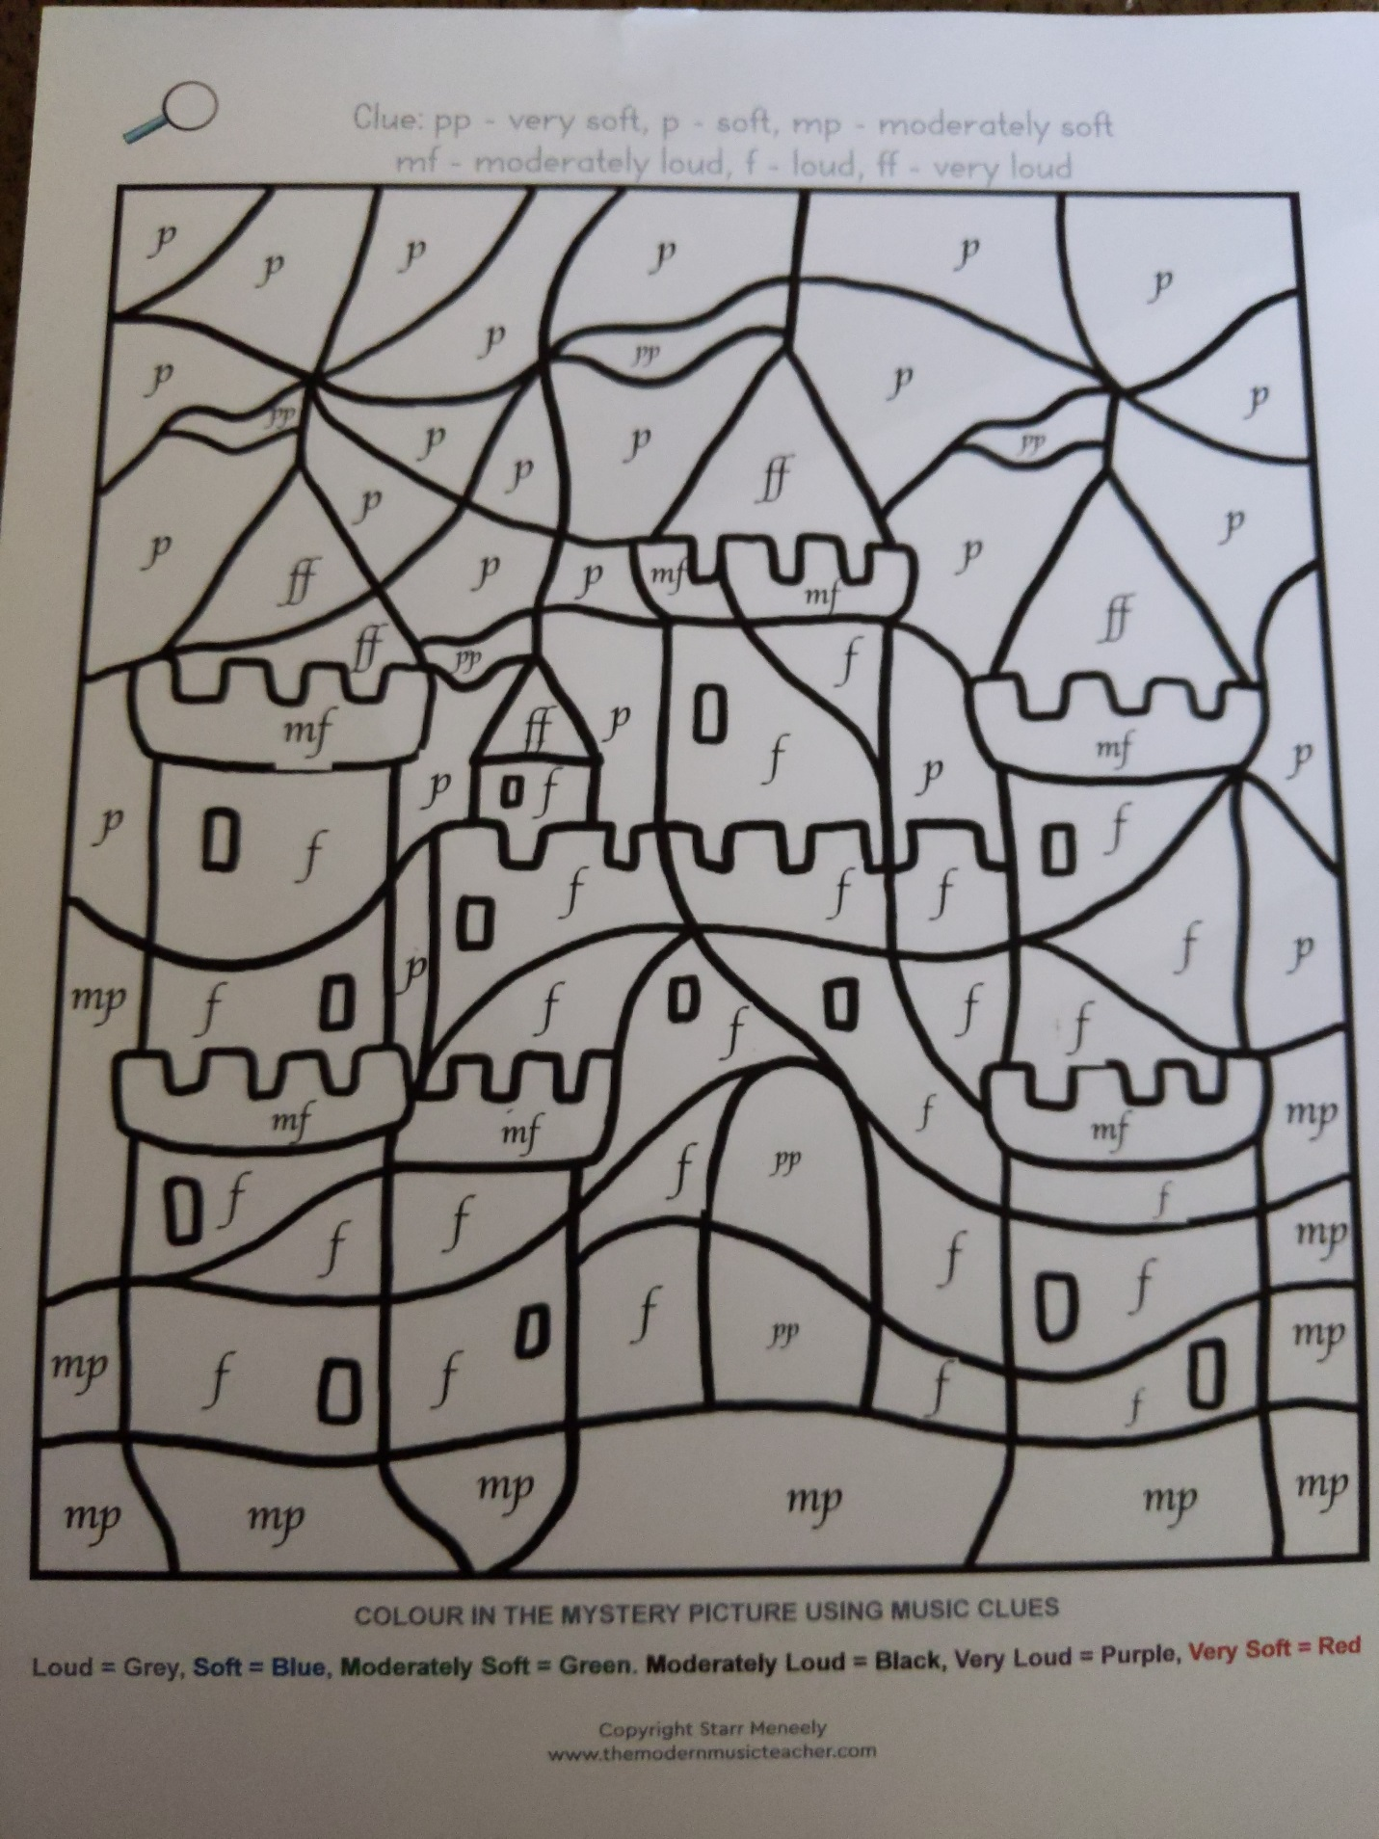
Practice the symbols by telling someone what they mean.
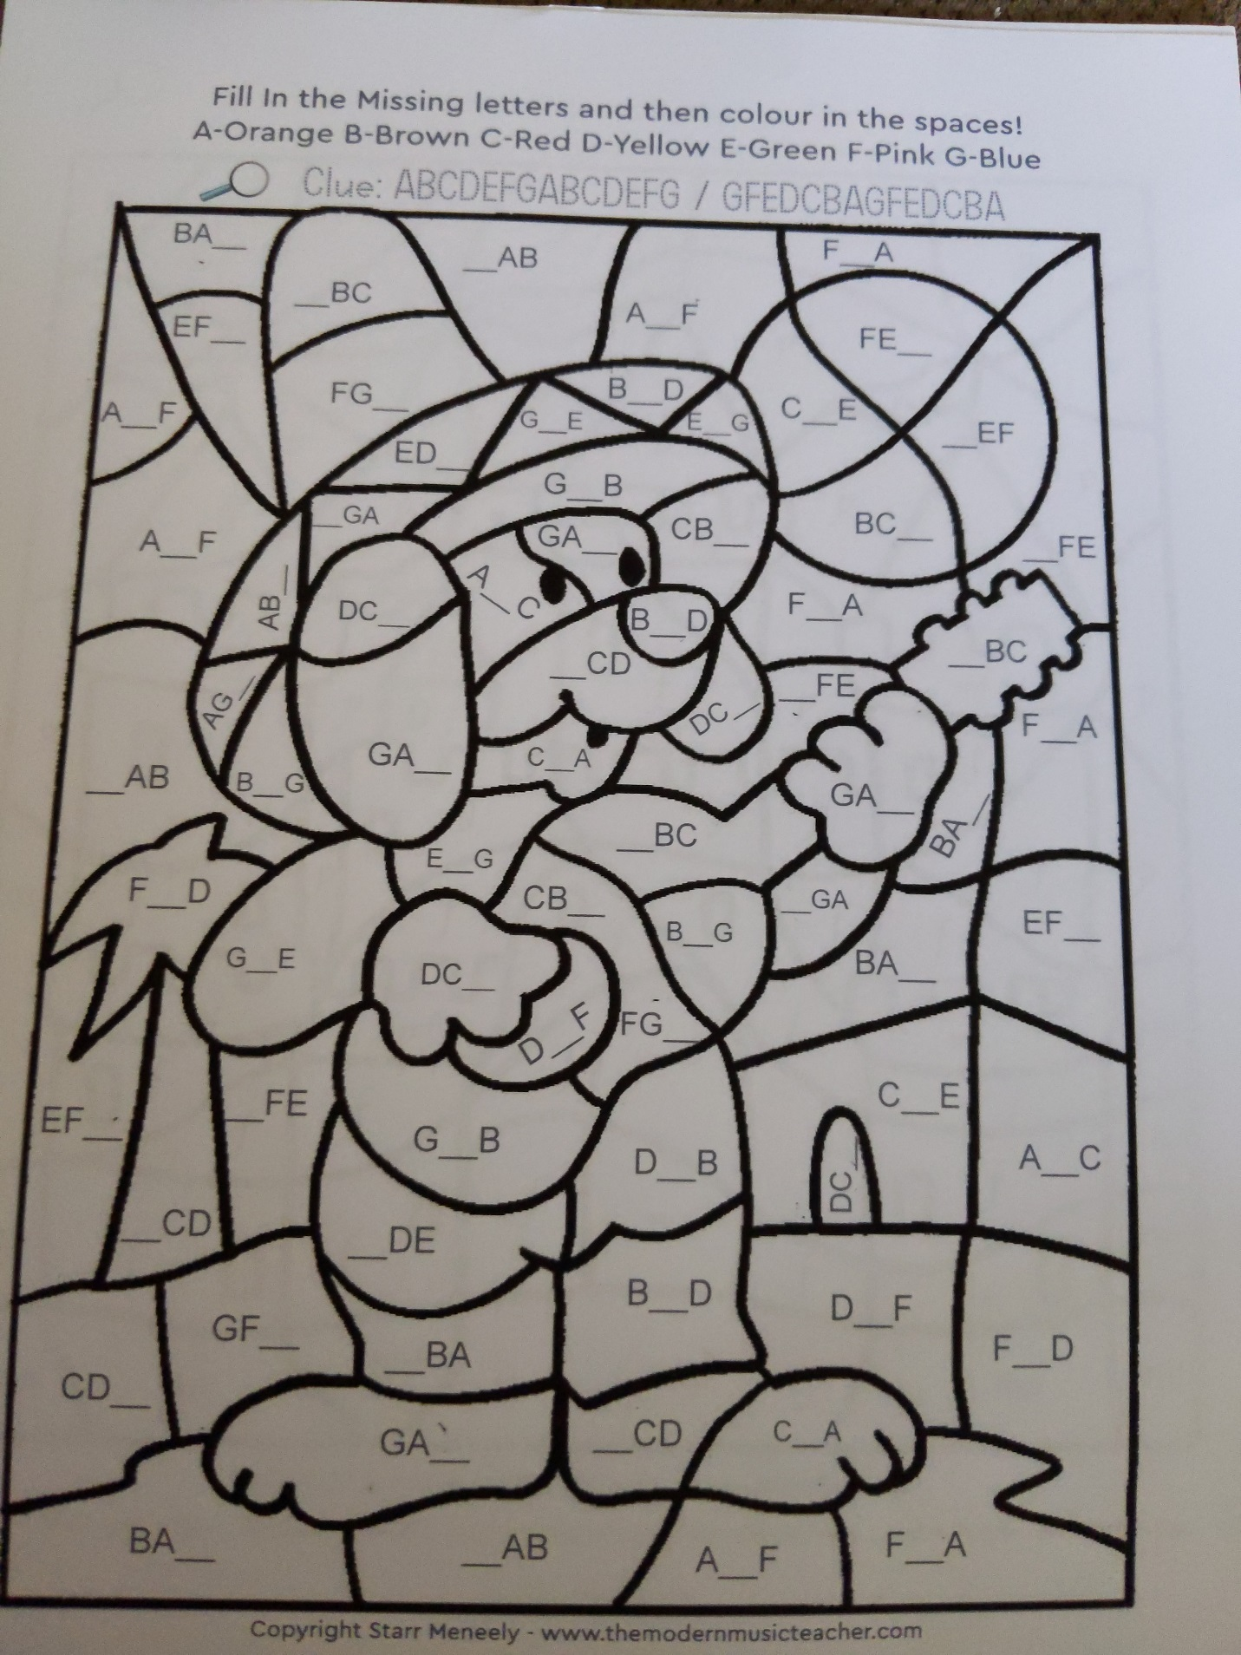
Practice the musical notes by telling someone what letter is in the blank.

