Math Projects for 4/6-4/10

- Measure five things in your house. Put them in order from longest to shortest.
Longest _________________ is ________ inches
_________________ is ________ inches
_________________ is ________ inches
_________________ is ________ inches
Shortest _________________ is ________ inches
- Look at a clock and write three times and what you were doing at that time.
At __________________ I was _____________________.
At __________________ I was _____________________.
At __________________ I was _____________________.
- Make a picture graph about your family’s favorite food.

Favorite Animals | 1 | 2 | 3 | 4 | 5

Which animal got the most votes?
Which got the least votes?
What is the difference between them?

- How many flat shapes does each shape have?
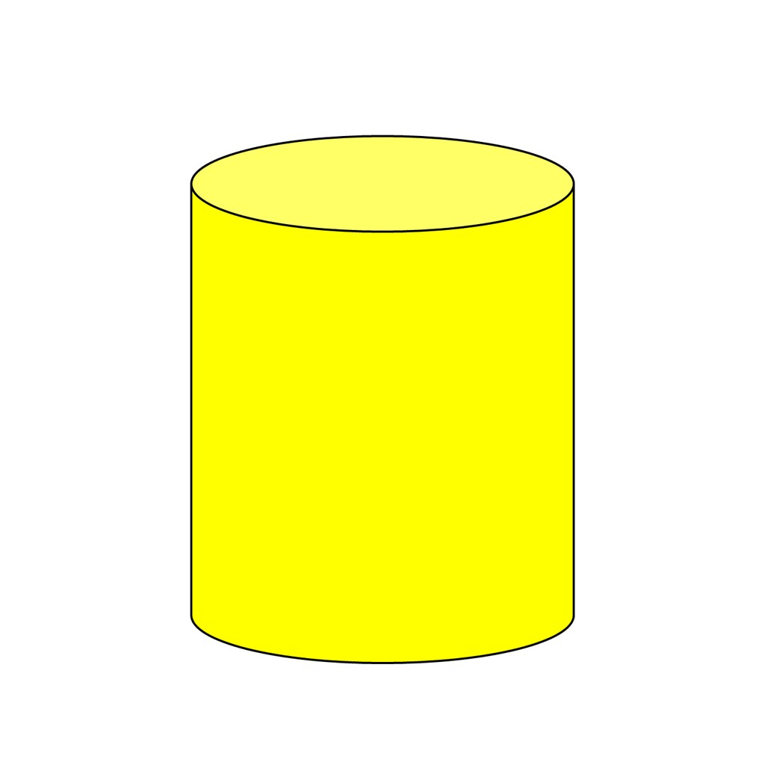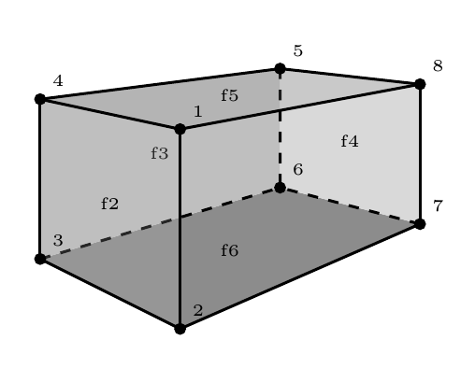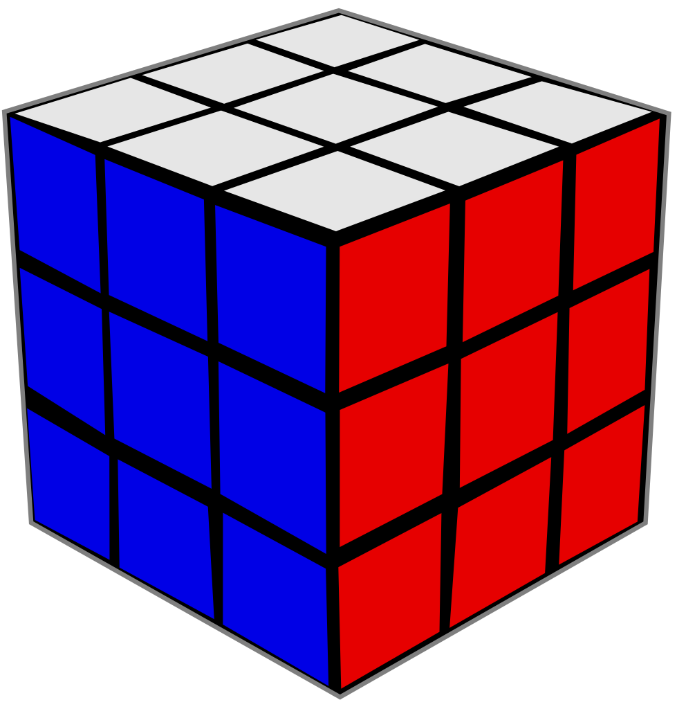
cylinder rectangular prism cube cone sphere

Which shapes have rectangles?
Which shapes have circles?
Which shapes have squares?
Draw or make a sandcastle using the 3-D shapes.

- Add and subtract the following numbers:

50 10 30 60 90 70
+40 +40 +70 -30 -20 -50

Language Arts projects for 4/6-4/10
- Write 5 words with a th ______ pattern like this.
- Write 5 words with an _____________th pattern like earth.
- Write 10 words a ______e______ like beg.
- Write how to make your favorite sandwich.
I like _____________________________________________ best.
First, _________________________________________________.
Then, _________________________________________________.
Next, _________________________________________________.
Last, _________________________________________________.
- Read about trains and write and draw how transportation has changed. (I attached the story.)
- Handwriting- Write John 3:16 as neatly as you can.

