Math Projects for 4/13-4/17: Answer the questions on another piece of paper. Send a picture me by email or text.
- Make tally marks to show how many pillows are in your house.
- What time does the clock say? 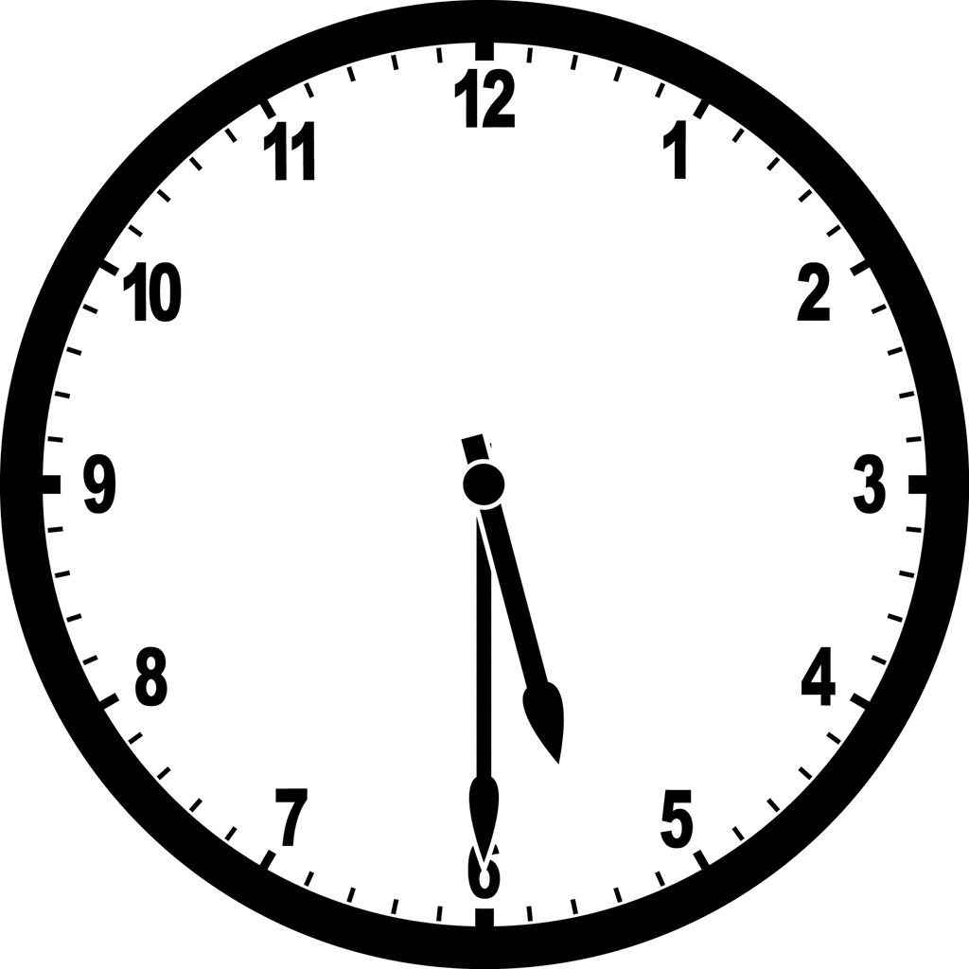
- How many sides and vertices (corners) does each have?
  - Pentagon
  - Hexagon
  - Triangle

- What is each shape? trapezoid, square, rectangle

  - b. c.

- Compare the following numbers using <, >, or =:

125______131 671_______671 201_______199

- Fill in the missing numbers:
count by 5’s- 70, 75, ________, _______, 90
count by 10’s- 90, 100, _______
count by 100’s- _______, 500, 600

- How many faces (flat sides) does each shape have? 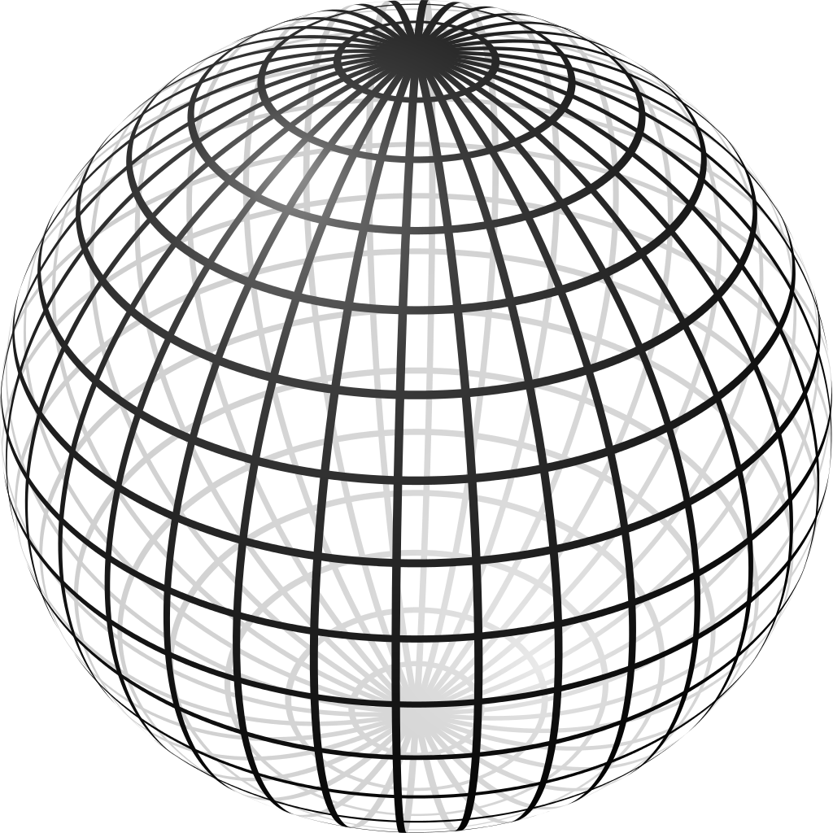 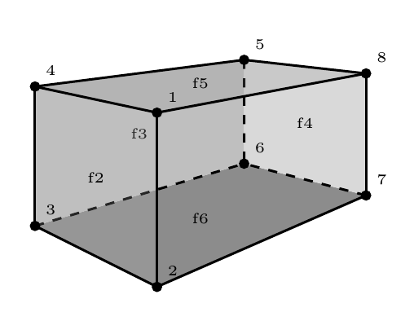 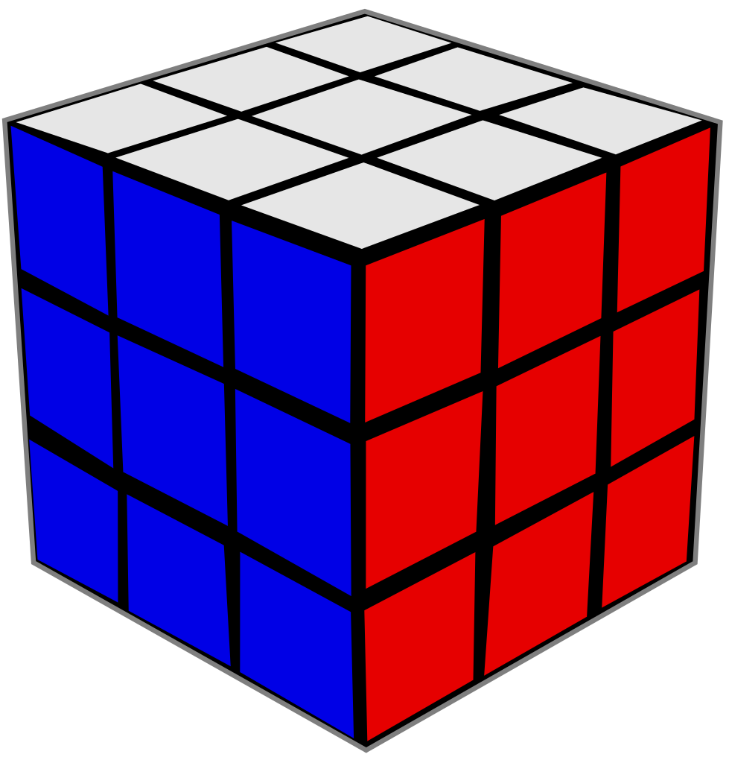
  - cylinder
  - rectangular prism
  - cube
  - cone
  - sphere
X
- How many books are 8 inches long? X X X
X X X X
5 6 7 8
Length for Books
Language Arts projects for 4/13-4/17

- Spelling- boys, door, enjoy, form, horse, Lord, noise, orange, important, voice, store, toy, before
  - Which words have an: oi oy or

  - Put the words in alphabetical order.

- Phonics- Write the bold word that finishes the sentence.
  - If I want to take a hike, then you want to ride your (like, Mike, bike).
  - If I want to run a mile, then you want to rest a (while, smile, pile).
  - If I want to slide or skate, then you tell me that it is (slate, late, gate).
  - If I want to play a game, you never want to do the (shame, name, same).
  - Luke hit a (hose, hill, home) run. He had a big smile on his face.
  - Kate (rod, rode, code) her bike to the pet shop. She went inside to get her pet.
  - She saw (cute, flute, cut) mice, kittens, fish, and dogs.

- Reading- Read about Sojourner Truth and answer the question. (I attached the story.)

- English- Journal what you are doing every day. Write at least 3 sentences every day.

- English- Jack Jack got out of his cage during spring break. It was night when he got out and he was not found all day. The next night he got thirsty and came back to the living room to get a drink of water and was put back in his cage. Write a story of what he did all day.

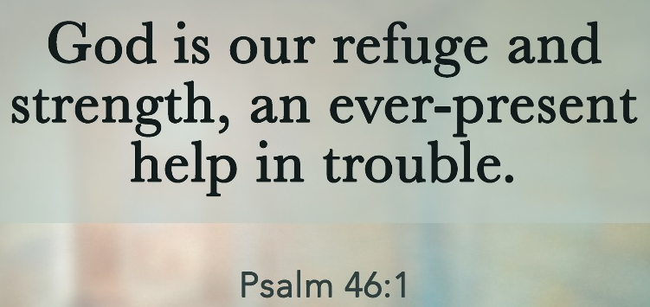

- Handwriting- Write Psalm 46:1 as neatly as you can.

