Language Arts instructions for 4/13-4/17 (#1 for 1st and 2nd only)
- Write the answers to the questions and take a picture of it. Send the picture to me by email or text it to me.
- Read at least 3 stories using raz-kids or any other stories if you can't get online. Please make sure your student is only reading stories for their raz-kid account. I do keep track of how much they read.
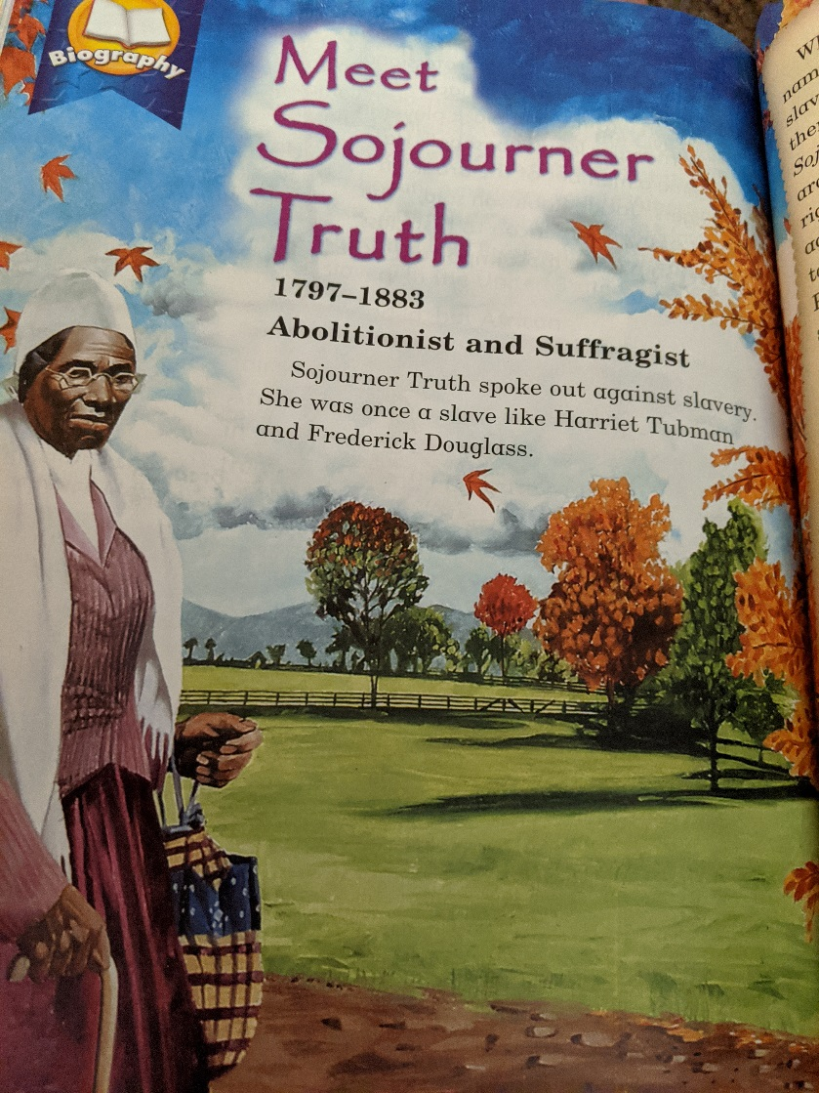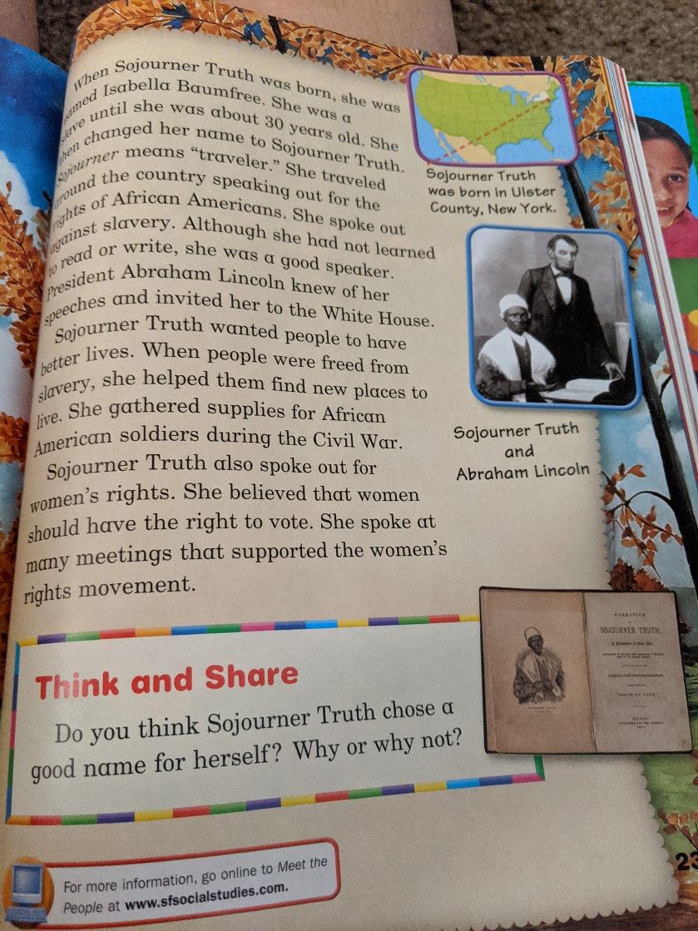

Science project instructions for 4/13-4/17: Read about the brain and answer the questions on another paper. Take a picture of the page and email or text it to me.
- Read the page about the brain. Answer the following questions?
- What does the brain do?
- What are nerves?

- Ask someone to drop a pencil above your hand 5 times. Try to catch between your fingers.
- How many times did you catch it?
- How did your brain help you catch the pencil?

- Draw the brain where it goes in the body.
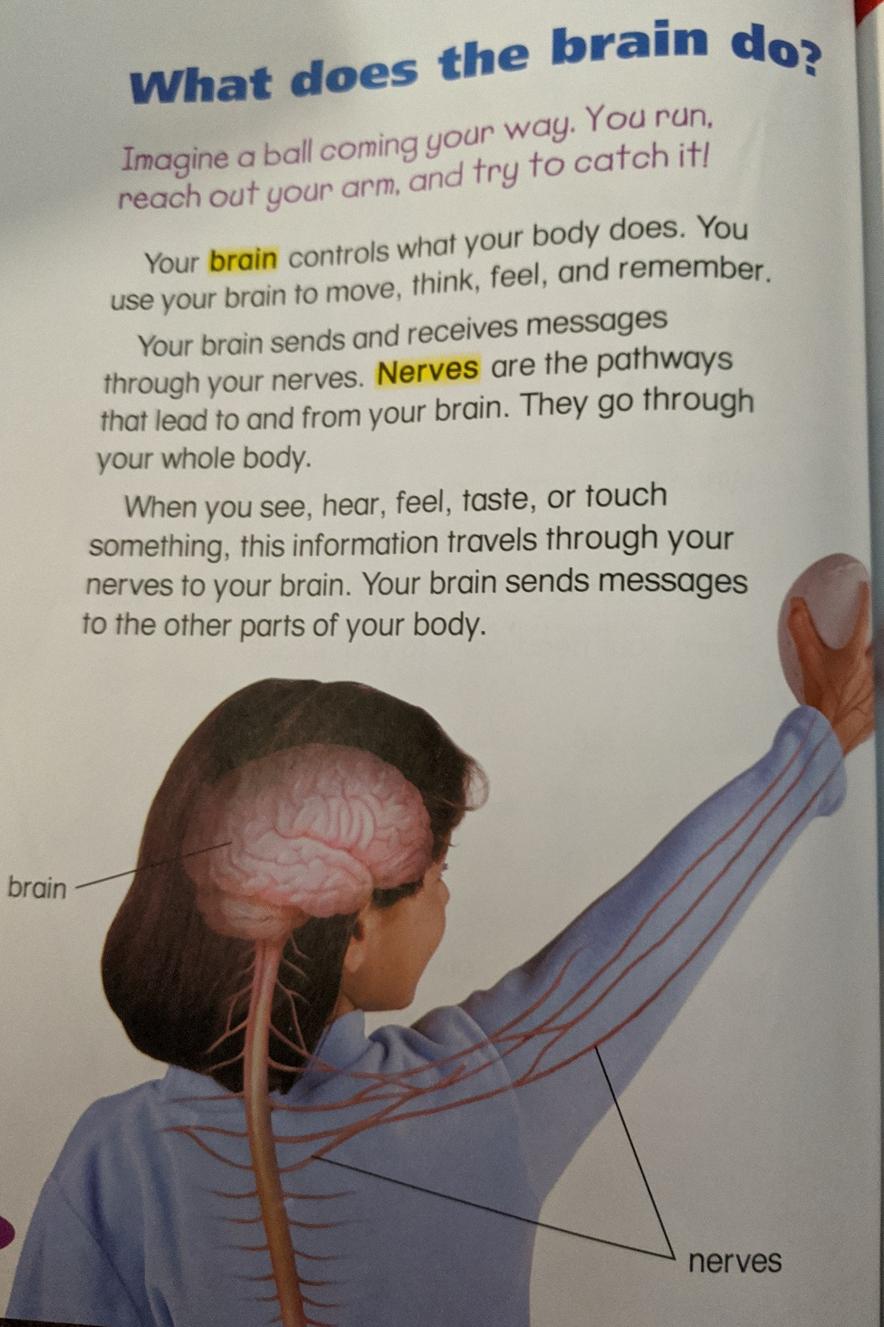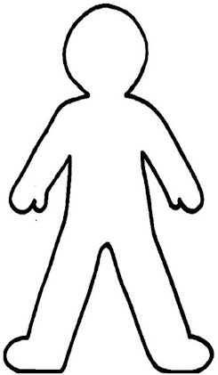

Social Studies projects instructions for 4/13-4/17: (#2 for 1st and 2nd only)
- Ask your parents about a family story and fill on the report. We will share our reports on Wednesday and Friday during our zoom meetings.
Family Report
- People in my family: __________________________________________________
- My family comes from: _______________________________________________
- I asked my __________________________ for a family story.
- The story happened in ______________________________ (place).
- The story happened in ________________________ (when).
- My family story: _____________________________________________________
___________________________________________________________________
____________________________________________________________________________________________________________________________________________________________________________________________________________________________________________________________________________________

- Write what each word means. Text or email what they mean.
- Shelter-
- Colonist-
- Tradition-
- Independence-
- Explorer-
- Pioneer-
- Colony-

]

